**KAMPALA URBAN SCHOOLS**

**BEGINNING OF FEBRUARY EXAMINATIONS, 2024**

**PRIMARY FOUR SOCIAL STUDIES**

**NAME:____________________________________STREAM:______**

**SECTION A**

1. Who was believed to be the first Muganda?

_______________________________________________________

1. Name the place where aeroplanes park.

________________________________________________________

1. Mention one animal which guards people’s homes.

________________________________________________________

1. Why does a P.3 pupil go to school?

________________________________________________________

1. Name the type of house shown below.  
   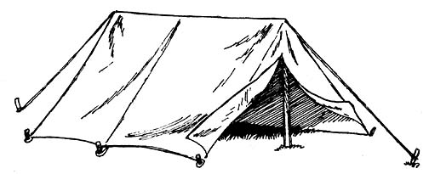___________________________
2. What is a map?

________________________________________________________

1. Write LC in full.

________________________________________________________

1. Why should a pilot use a compass direction?

________________________________________________________

1. Which type of weather helps farmers to dry their harvested crops?

________________________________________________________

10. Mention the type of leader the LC I Chairperson is.

_______________________________________________________

11. What are economic activities?

________________________________________________________

12. How are fathers important in family?

________________________________________________________

13. What is a hill?

________________________________________________________

14. Mention the means of air transport shown below.

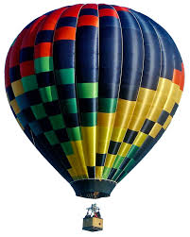________________________________________________

15. Name one example of people found in the school community

_______________________________________________________

16. Name the basic need provided by oculists.

_______________________________________________________

17. Anne was walking late in the evening and her shadow was in front of her. In which direction was she going to?

________________________________________________________

18. What lesson do you learn from the story of Kintu and Nambi?

________________________________________________________

19. What social services do we get from the post offices?

________________________________________________________

20. Write down any one form of child abuse.

________________________________________________________

21. How useful is the object below to people?

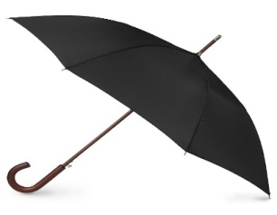

______________________________________________________

22. Mention of importance of a police station to the community.

________________________________________________________

23. Give the main duty of the army to people in your community.

________________________________________________________

24. What do you call a place where vehicles go to for fuel?

________________________________________________________

25. Give one reason why most people use road transport in your community?

________________________________________________________

26. From which cash crop do people get sugar?

________________________________________________________

27. How are cooks useful at school?

_______________________________________________________

28. Name this object found at home.

|  |
| --- |
|  |
|  |

29. What name is given to a vehicle which transports patients to hospital?

______________________________________________________

30. How are radios similar to blowing horns?

________________________________________________________

31. What is the work of a carpenter?

________________________________________________________

32. Name one hospital in your municipality.

______________________________________________________

33. How is Lake Katwe useful to the people of Uganda?

________________________________________________________

34. Give one place where people can keep their money safely.

________________________________________________________

35. Mention one way you can keep your bedroom clean.

________________________________________________________

36. Write R.E in full.

________________________________________________________

37. What is prayer?

________________________________________________________

38. Apart from the sick, give any other special group of people who need to be prayed for.

_______________________________________________________

39. Give one example of God’s/ Allah’s messengers today.

________________________________________________________

40. Write example of a holy book found in your place of worship.

______________________________________________________

**SECTION B**

41.(a) Name any two people who use a compass direction.

(i) _____________________________________________________

(ii)_____________________________________________________

(b.) Give any two elements of a good map.

(i) ______________________________________________________

(ii) ______________________________________________________

42.(a) Write three examples of physical features.

(i) _____________________________________________________

(ii)____________________________________________________

(iii) _____________________________________________________ (b) Give one use of a river.

_________________________________________________________

43. (a) Mention one example of children’s right.

_________________________________________________________

(b) Give two causes of child abuse.

(i) ______________________________________________________

(ii)______________________________________________________

(c.) How can you stop child abuse in your community?

___________________________________________________________

44. (a) What is communication?

____________________________________________________________

b. Write two modern means of communication in your community.

(i)________________________________________________________ (ii)________________________________________________________

(c.) Draw one traditional means of communication.

|  |
| --- |
|  |
|  |

45. Match the people to their economic activities.

|  |  |
| --- | --- |
| People | Activity |
| Farmers | build houses |
| Builders | make things out metal |
| fishmongers | grow crops and keep animals |
| Welders | sell fish |

(i) farmers ____________________________________________

(ii) builders ____________________________________________

(iii) fishmongers_________________________________________

(iv)welders___________________________________________

46. (a) What is a project?

_______________________________________________________

(b.) Write any two examples of projects you can start at home.

(i)_____________________________________________________

(ii)______________________________________________________

(c) Mention one way you can manage a project.

_______________________________________________________

47. (a) Name the weapons used to keep peace and security.

|  |  |
| --- | --- |
| C:\Users\akpsn\Desktop\2018\bbb.png | https://static01.nyt.com/images/2018/03/28/opinion/28Stevens/28Stevens-jumbo.jpg?quality=90&auto=webp |
|  |  |

(b)Name the service provided by the above weapons.

_______________________________________________________

(c) Give one form of insecurity.

_______________________________________________________

48. (a) Mention any two local methods of preserving fish.

(i)______________________________________________________

(ii)_______________________________________________________

(b) Draw two things fishermen use to catch fish.

|  |  |
| --- | --- |
|  |  |
| Basket | Spear |

49.(a) Write any two things people spend money on.

(i)___________________________________________________

(ii)___________________________________________________

(b) Mention two ways people can spend money wisely.

(i)_____________________________________________________

(ii)______________________________________________________

50.(a) Name two things people can make from animal skin.

(i)________________________________________________________

(ii)_______________________________________________________

(b) Give two natural materials which can be got from the swamps.

(i)_____________________________________________________

(ii)________________________________________________________

51(a) What do you call the way of life of people in a given society?

____________________________________________________________

(b)Apart from dressing give one cultural practice in your community.

_____________________________________________________________

(c)Why do people perform cultural dances?

_____________________________________________________________

52(a) Draw and name the traffic lights in the space below.

|  |
| --- |
|  |
|  |

(b) Give any one use of the traffic police.

_____________________________________________________

53(a) Name two places people can go to worship their God/Allah

(i)______________________________________________________

(ii)________________________________________________________

(b) Give two names used to mean God/ Allah.

(i)___________________________________________________________

(ii)__________________________________________________________

54(a) Mention two types of prayers.

(i)__________________________________________________________

(ii)__________________________________________________________

(b)Name the personal prayer believers say to thank their God/Allah.

_____________________________________________________________

(c)Give one reason why people to their God/ Allah

_____________________________________________________________

55(a) Write any two religious groups in your community.

(i)___________________________________________________________

(ii)__________________________________________________________

(b)Draw and name any two animals found in water bodies.

|  |  |
| --- | --- |
|  |  |
|  |  |

**GOOD LUCK**